**Week 12**

**Networking Programming**

**Name: Ronit Kumar Reg: RA2111032010009 Batch: CSE w/s IOT [T2]**

**1. Create a Simple Client Server Application using TCP Socket where the server issues**

**a command which will be executed at the client slide as a process of remote**

**command execution.**

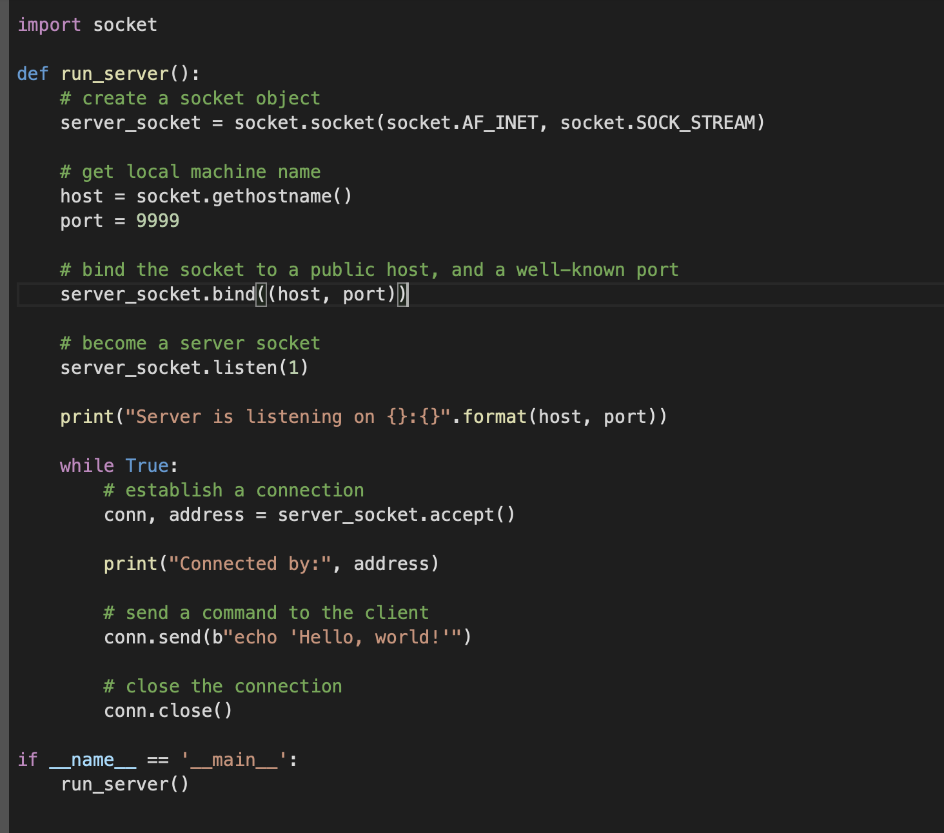

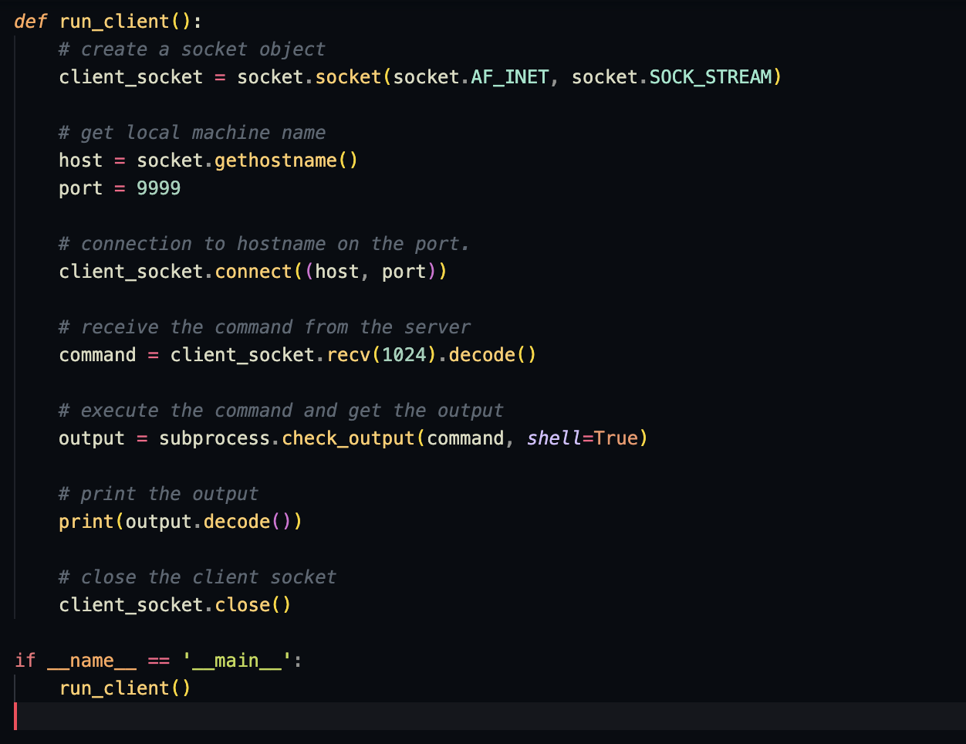

**Output:**

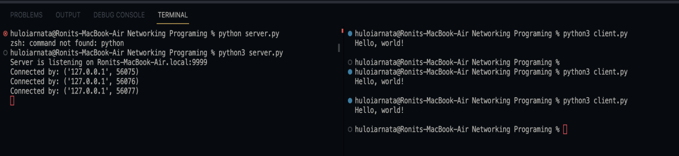

**2. Write a Socket-based Python server program that responds to client messages as**

**follows: When it receives a message from a client, it simply converts the message into**

**all uppercase leters and sends back the same to the client. Write both client and**

**server programs demonstrating this.**

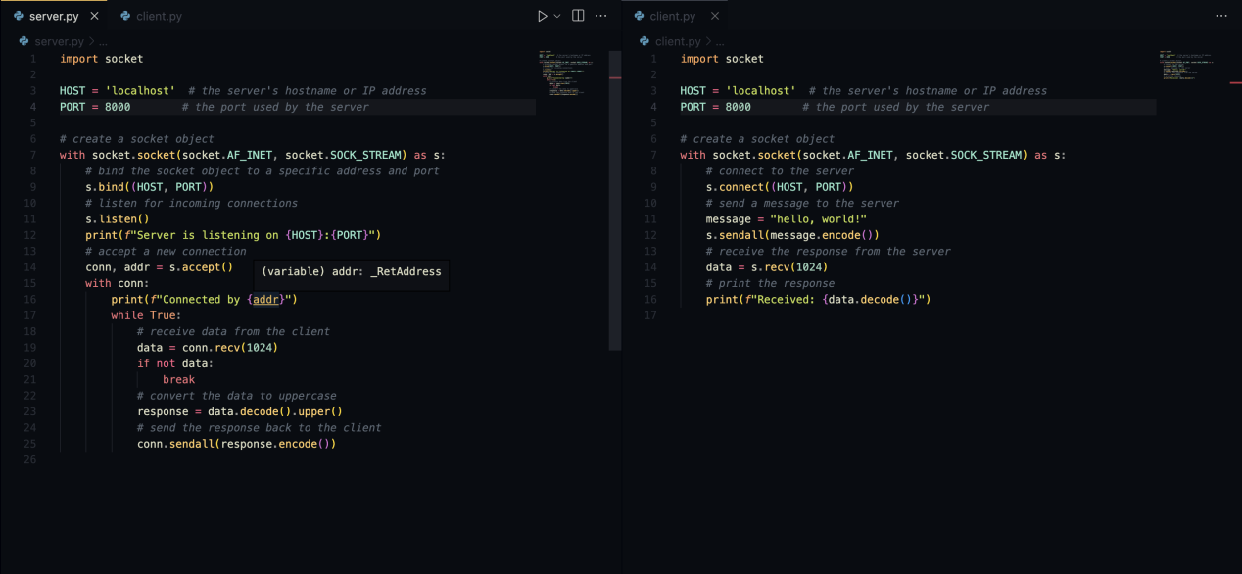

**Output:**

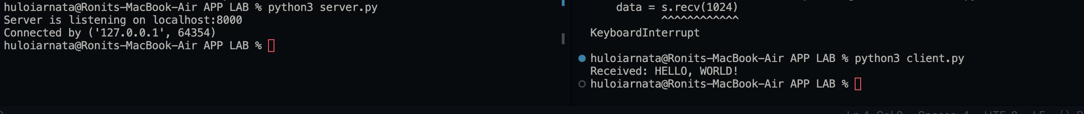

**3. Write a ping-pong client and server application. When a client sends a ping**

**message to the server, the server will respond with a pong message. Other messages**

**sent by the client can be safely dropped by the server.**

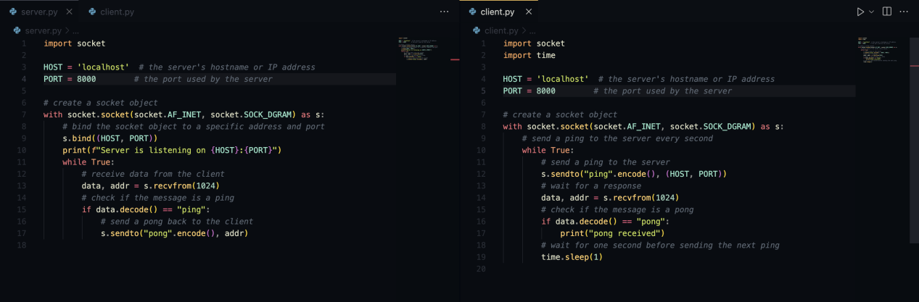

**Output:**

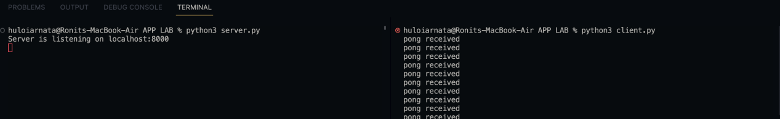

**4. Write a Socket based program server-client to simulate a simple chat application**

**where the server is multithreaded which can serve multiple clients at the same time.**

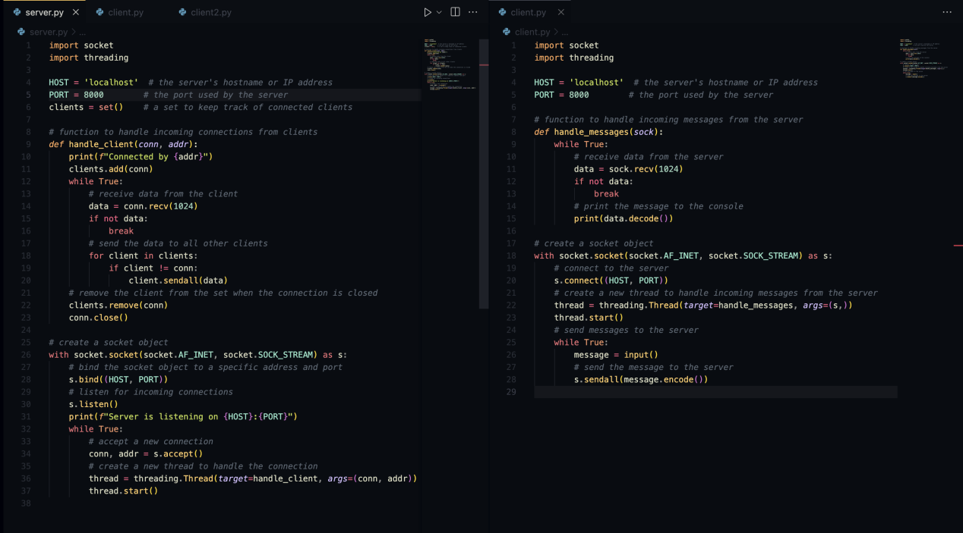

**Output:**

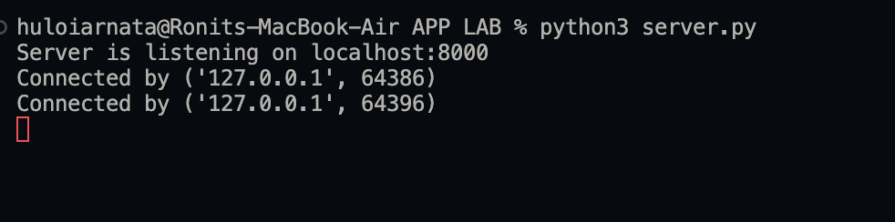

**5. Write a Socket based program server-client to simulate Simple File Transfer**

**Protocol using TCP Sockets.**

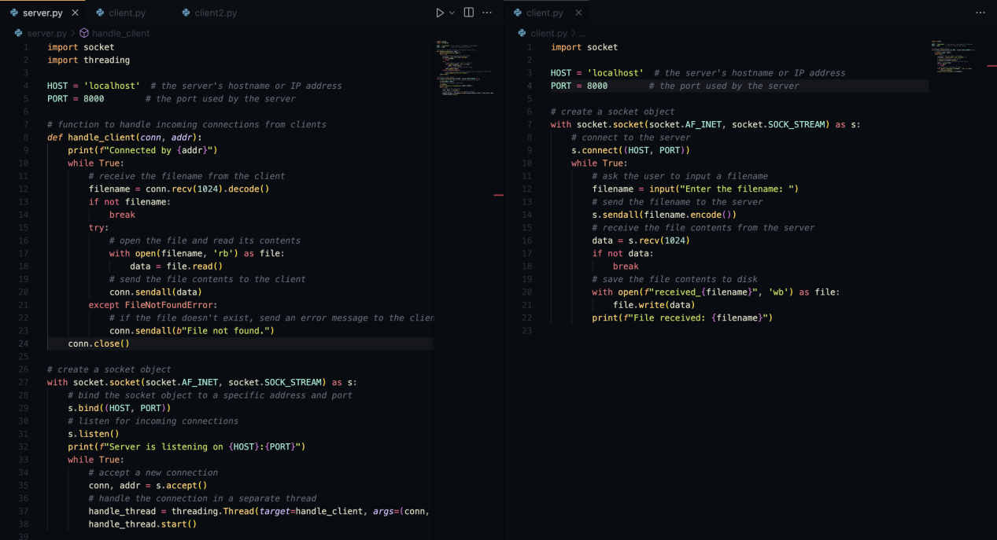

**Output:**

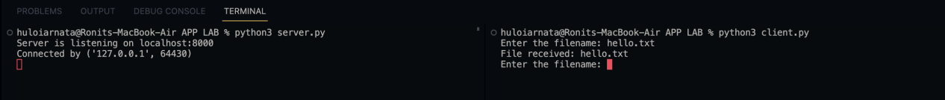

**6. Write a Socket based program server-client to simulate DNS Service where client**

**request for Domain name using IP address and server responds with the Name.**

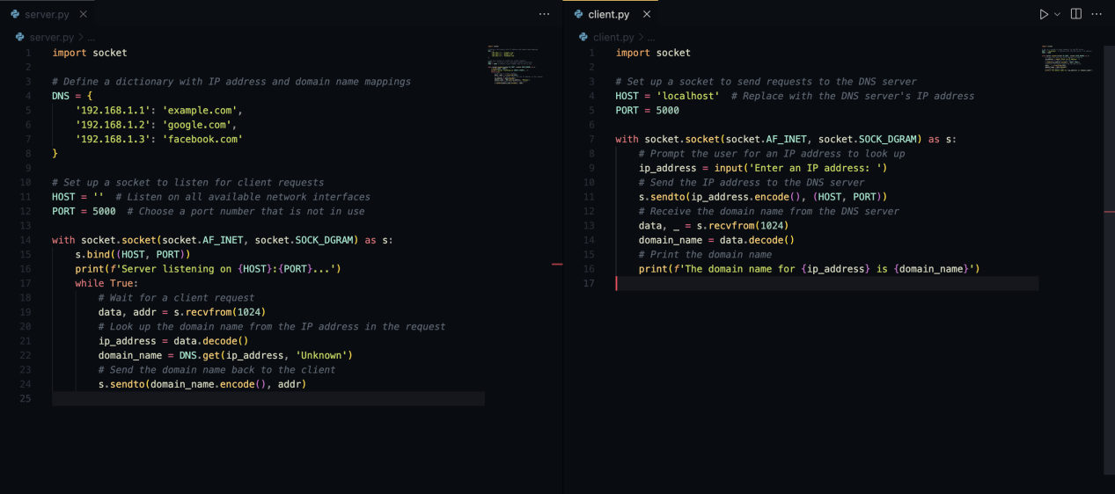

**Output:**

